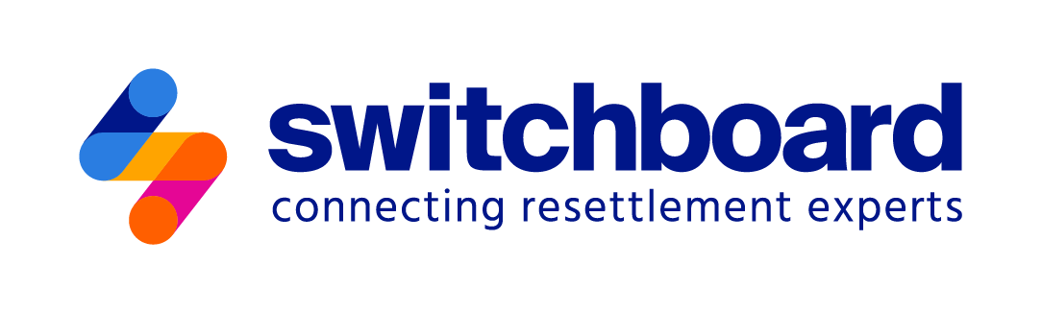

Intake Form: Newcomer Educational and Professional Background

*This intake form helps service providers collect key information about individuals’ personal, educational, and professional backgrounds. It is intended to guide support in areas like career development, credential evaluation, and education. Completing the form should take about 10–15 minutes. After completing the form, make sure to gather the relevant documentation the client can access.*

*Note: This form is intended to be used as a template and customized to align with your program’s unique needs and specific compliance requirements. This document should not be regarded as a complete compliance tool for any particular grant or program. Please refer to your agency’s cooperative agreements for program-specific requirements.*

PERSONAL INFORMATION

Full Name:

Date of Birth: Gender:

Address:

Phone Number: Email Address:

Country of Origin: Date of Arrival:

Immigration Status: Work Authorized:  Yes  No

EDUCATIONAL BACKGROUND

*Select all that apply:*

High School Diploma *or equivalent*   U.S. Institution  Non-U.S. Institution

Associate’s Degree *or equivalent*   U.S. Institution  Non-U.S. Institution

Bachelor’s Degree *or equivalent*   U.S. Institution  Non-U.S. Institution

Master’s Degree *or equivalent*   U.S. Institution  Non-U.S. Institution

PhD *or equivalent terminal degree*   U.S. Institution  Non-U.S. Institution

Other Professional Certificates U.S. Institution  Non-U.S. Institution

Training Courses or Certificates obtained in refugee camp setting

Description of Education:

Details of Last Educational Institution Attended:

Name of Institution:

Country:

Degree/Certification Earned:

Field of Study:

Year of Graduation:

Professional Certifications (e.g., PMP, CPA, etc.):

Certification Name:

Issuing Organization:

Country: Year Issued:

Do you have any documents that confirm your educational background (diplomas, transcripts, etc.)?

Yes  No – *If no, can you request transcripts from your institution?*  Yes  No

In what format are these documents?

Hard copies  Digital copies

If you have hard copies, are they currently with you in the U.S.?

Yes  No  No, but I could obtain them

Not applicable (I only have digital copies)

Are your education documents in English or another language? *(Documents must be translated if used for credential evaluation.)*

Documents are in English

Documents are in another language

Have you taken an English Placement Exam?

Yes – *If yes, which exam did you take (e.g., TOEFL, IELTS, etc.):*

No

WORK EXPERIENCE

Do you have a resume or CV?

Yes  No

Most Recent Job Title:

Employer Name:

Country:

Years of Experience in This Role:

Brief Description of Duties and Responsibilities:

Additional Relevant Work Experience

Job Title:

Employer Name:

Country:

Years of Experience in This Role:

Brief Description of Duties and Responsibilities:

Job Title:

Employer Name:

Country:

Years of Experience in This Role:

Brief Description of Duties and Responsibilities:

Job Title:

Employer Name:

Country:

Years of Experience in This Role:

Brief Description of Duties and Responsibilities:

Skills

What skills have you gained from previous jobs, volunteer work, or personal projects? *(Examples: auto repair, project management, problem-solving, digital skills)*

List any skills related to working with people. *(Examples: teamwork, customer service, leadership)*

Describe any domestic or manual skills you’ve developed. *(Examples: agricultural skills, sewing, caretaking, cooking)*

Other Skills:

CREDENTIAL EVALUATION AND RECOGNITION

Have you had your educational credentials evaluated in the U.S.?

Yes *If yes, by which organization?*

No If no, are you interested in having your credentials evaluated?  Yes  No  Maybe

What is your purpose of obtaining a credential evaluation? *(Check all that apply.)*

Higher Education

Employment

Professional Re-Licensure

Other:

Are you aware of funding options for credential evaluations?

Yes  No

Do you need assistance in finding financial aid or scholarships?

Yes  No

NEXT STEPS

What are your career or professional goals?

What type of support do you need to achieve your career goals? *(Check all that apply.)*

Credential Evaluation

Professional Licensing

Job Search Assistance

Further Education Guidance

English Language Training

Other:

Are you interested in further education?

Yes  No  Maybe

*If yes, what field of study are you interested in?*

ADDITIONAL SUPPORT AND RESOURCES

Would you like to be connected with career coaching services?

Yes  No

Would you like information on local organizations that support refugees?

Yes  No

Any other support or information you need?

CONSENT

By signing below, I consent to the collection and use of my personal information for the purpose of providing resettlement services and support.

Signature: Date:

*The IRC received competitive funding through the U.S. Department of Health and Human Services, Administration for Children and Families, Grant #90RB0053. The project is 100% financed by federal funds. The contents of this document are solely the responsibility of the authors and do not necessarily represent the official views of the U.S. Department of Health and Human Services, Administration for Children and Families.*